Name:
Course/section:
Date
HW #: 3
Chapter 6: Fundamental Principles of Thermodynamics

- A hard-boiled egg removed from a pot of boiling water at 96°C is placed in a 40°F refrigerator to cool. Find the temperature of the egg in units of K, °C, and °R after the egg has attained thermal equilibrium with the refrigerator. What is the temperature change of the egg in units of °F, °C, and K?

T(K) = T($°C)+273$

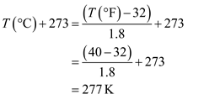
Temperature of the egg in units of K = 277K
Temperature of the egg in units of °C = 277K -273K = 4°C
Temperature of the egg in units of °R = 40°F + 459.67 = 499.67°R
Change in Temperature = 96°C - 4°C = 92°C
92°C = 92 + 273 = 365 K
365 K = 197.33 °F
- What gauge pressure would you need to inflate an automobile tire in San Diego, California, to achieve an absolute pressure of 400 kPa? (Assume that San Diego is a city at sea level)

By taking San Diego to be at sea level ,we would have barometric P of 101.325 kPa Therefor:
Absolute P - Bar P = gauge P
400 – 101.325 = 298.675 kPa
= 298.675 kPa

- A vertical, frictionless piston-cylinder device contains a gas. The piston has a mass of 3 kg and a radius of 5 cm. A downward force of 75 N is applied to the piston. If the atmospheric pressure is 100 kPa, find the pressure inside the cylinder.

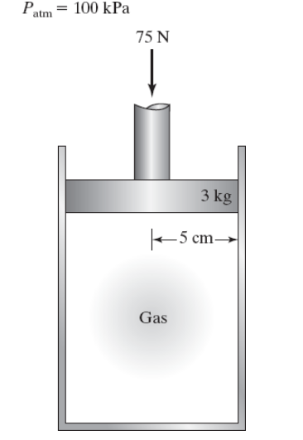

Atmospheric pressure = 100kPa= 100,000N/m²
The mass of the piston is 3kg
Taking acceleration due to gravity as 10m/sec²(for calculation convenience) the weight of piston is,3x10=30N
Now additional 75N of force is applied on the piston.
Total force on piston = 30 + 75 = 105N
The Radius on the piston is 5cm
Area = $πr^{2}$ = $π*{0.05}^{2}=$0.00786 m²
the pressure due to weight of piston and force applied on it
= $\frac{105N}{0.00786m^{2}}$= 13358.78 N/m ²
The additional atmospheric pressure is 100,000N/m²
Total pressure = 100,000N/m²+13358.78 N/m ² = 113,358.78 Pa
Under equilibrium condition, the pressure inside the cylinder is equal to external pressure =113,358.78 Pa.

- Kinetic and Potential Energy
  - A boulder elevated above the ground has gravitational potential energy. The center of mass of the boulder is 20 m above the ground. If the boulder’s mass is 1500 kg, what is the gravitational potential energy of the boulder?

P.E = mgh
M= mass
g = gravity = 9.81 m/sec²
h = height above ground
P.E = 1500 * 20* 9.81 = 294300 Joules
= 294.3kJ

  - A boulder is pushed off the cliff and begins to fall toward the ground. As the boulder falls, its velocity increases, and its potential energy is converted to kinetic energy. If the velocity of the 1500-kg boulder is 10.0 m/s at a point between the cliff and ground, what is the boulder’s kinetic energy at this point

K.E = $\frac{1}{2}$mv²
K.E = 0.5*1500* 10² = 75000 Joules
= 75 kJ

- As a 2500-kg truck climbs a hill, it changes speed from 20 mi/h to 50 mi/h along a straight 1600-ft section of road. If the hill is inclined at an angle of 8° with respect to the horizontal, find the total work.
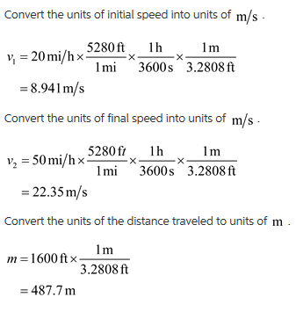
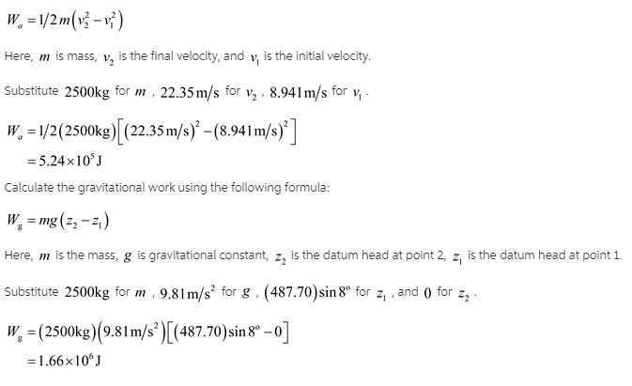
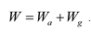
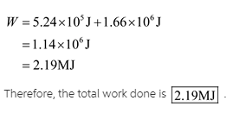

- The pressure inside a frictionless piston-cylinder device varies according to the function P = a - bV, where a and b are constants and V is volume. The initial and final volumes for the process are 1 m³ and 0.1 m³, respectively. If a = 500 Pa and b = 2000 Pa/m³, find the boundary work.
P = a - bV
a = 500 Pa and b = 2000 Pa/m³,
Initial and final volumes for the process are 1 m³ and 0.1 m³
Initial P = 500Pa – 2000Pa/m³* 1 m³ = -1500 Pa
Final P = 500Pa – 2000Pa/m³* 0.1 m³ = 300 Pa
Boundary work = Final P – Initial P
= 300Pa –(-1500Pa) = 1800 Pa
Boundry work = Pressure * Change in volume
Boundary work = 1800 * 0.9 m³= 1620 J
= 1620 J

- A shaft rotating at 1200 rpm (revolutions per minute) experiences a constant torque of 60 N · m. How much work does the shaft perform in 1 h?

P=$\frac{2*π*N*T}{60}$
Where N is rpm, P is power in Watts and T is torque
P = $\frac{2*π*1200*60}{60}$ = 7539.82 W
Work = Power * Time
Work = 7539.82 *1*3600 = 27,143,360.53 Joules
= 27.143MJ

- A linear elastic spring is compressed 3.5 cm from its at-rest position. The spring is then compressed an additional 7.5 cm. If the spring constant is 2600 N/cm, find the work done in compressing the spring.

W= $\frac{1}{2}kx^{2}$
x = 7.5cm – 3.5 cm = 4cm
W= $\frac{1}{2}*2600* 4^{2}$ = 20800 Joules
= 20.8 kJ

- A piston-cylinder device containing water is heated. During the heating process, 300 J of energy is supplied to the water, while 175 J of heat is lost through the walls of the cylinder to the surroundings. As a result of the heating, the piston moves, doing 140 J of boundary work. Find the change in the internal energy of the water for this process.

Initial heat energy = 300J
Heat lost = 175J
Work done = 140J
300J – x = 140J + 175 J
300J – (140 + 175 ) = x
x = 300 – 315 = -15 J
Hence Change in the internal energy of water = -15J

- Joe, a backyard tinkerer who fancies himself an engineer, tells his engineer neighbor Jane that he has developed a heat engine that receives heat from boiling water at 1 atm pressure and rejects heat to a freezer at -5°C. Joe claims that his heat engine produces 1 Btu of work for every 2.5 Btu of heat it receives from the boiling water. After a quick calculation, Jane informs Joe that if he intends to design heat engines, he needs to pursue an engineering education first. Is Jane justified in making this comment? Justify your answer by analysis.

At 1 atm, boiling point of water = 100°C
Work done by boiling water = 2.5Btu = 2110.11 J
Specific heat capacity of water = 4182 J/(K kg)
Work done = Mass of water * change in Temperature * Specific heat capacity
Change in Temp = 100°C – (-5°C) = 105°C

2110.11 J = Mass of water * (105+273 K)* 4182 J/(K kg)
Mass of water = $\frac{2110.11}{4182*378}$ = 1.335 * 10⁻³Kg = 1.335 g

For 1 Btu, $\frac{1.335}{2.5}$ = 0.534 g of water is used.

I think Jane is right because the amount of water being used here is not logically, the engine would run dry.

